Project Planning Phase
Project Planning Template (Product Backlog, Sprint Planning, Stories, Story points)

Product Backlog, Sprint Schedule, and Estimation:

Sprint | Functional  Requirement (Epic) | User  Story  Number | User Story/Task | Story Point | Priority | Team Member
Sprint-1 | Prediction | USN-1 | Analyse/Predict for new data | 2 | High | NA
Sprint-1 |  | USN-2 | User get Predicted output | 1 | High | NA
Sprint-2 |  | USN-3 | User missed a field area in analyse | 1 | Medium | NA
Sprint-3 |  | USN-4 | User go to About page | 1 | Low | NA
Sprint-3 |  | USN-5 | User go to Contact Us page | 2 | Low | NA

Project Tracker, Velocity & Burndown Chart:

Sprint | Total  Story  Points | Duration | Sprint Start Date | Sprint End Date (Planned) | Story Point  Completed (as on planned End Date) | Sprint Release Date (Actual)
Sprint-1 | 20 | 4 Days | 25 Aug 2024 | 28 Aug 2024 | 20 | 28 Aug 2024
Sprint-2 | 20 | 4 Days | 30 Aug 2024 | 02 Sept 2024 | 20 | 02 Sept 2024
Sprint-3 | 20 | 4 Days | 04 Sept  2024 | 07 Sept 2024 | 20 | 07 Sept 2024

Velocity:

Let’s calculate the team’s average velocity (AV) per iteration unit (story points per day):

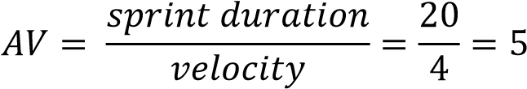

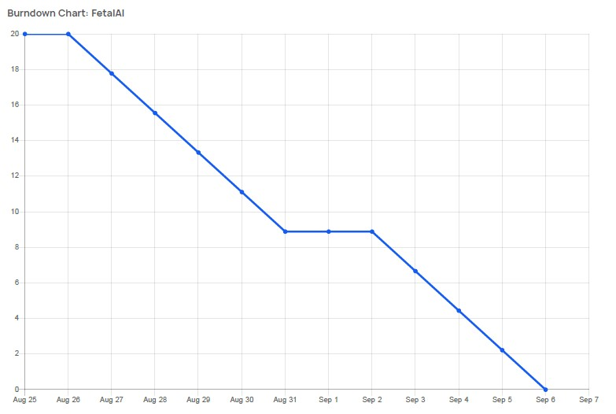
Burndown Chart:

